Healthcare Workflow Record System
Student’s Name
Institutional Affiliation

The system involves operations upheld to ensure the smooth running of any health organization. Operations included helps to identify tasks performed in offices, additionally giving the practices relevant relationships to provide end report. The workflow considers three key offices in healthcare; a primary care office, a specialty office and a multi special office. The diagrams are presented through UML activity diagrams (Ben-Assuli, 2015). The noted offices are highly computerized based on the services offered leading to a more complex organizational structure based on external variations in the workflow.
Tasks are described in accordance to roles played by the participants. Front desk operations include; patient registration, scheduling appointments, referrals, insurance verifications, prescription and related activities and mailing letters. Nurses activities include; collecting illness history, collecting co-pay activities and front desk activities (Hsiao et al., 2014). While the physician’s activities include; routine history and examination, entering progress notes, entering billing details, consulting fellow specialists and hospitals and reviewing faxes and issuing follow-up actions on activities rendered.
Tasks description
Appointments are scheduled for first time patients through telephone. Later, doctors follow up the patient’s appointments from the clerk’s desk and sets a date with an agreement from the patient. The patient is then updated on the appointment three days prior to the agreed date. In case of new patients visits, new registration is done, which requires collection of personal information of the patients, then the healthcare institution keeps the records (Hsiao et al., 2014). After registration, the patient is directed to a doctor for check-up and examination. When a patient revisits the organization, he or she repeats registration and the front desk clerk retrieves previous documents to compare with the current one. After checkup, the doctor provides prescriptions to the patients which are later reviewed and faxed to pharmacy for medicine request.
The front desk is also responsible in mailing referral orders to other hospitals and patients, attending telephone calls and issuing back to school/work or sickness certificates. Front desk clerks are also responsible in collecting co-payments and assists with time permits to visitors in the healthcare center. Physicians responsibility is centered in routine examination of the patients and advises the patient in accordance to the prescription delivered to him or her (Lo et al., 2007). Secondly, physician’s records billing details and progress notes of the patients to send to billing agency and for medication records respectively. The physician is also responsible in communicating with fellow consultants and hospitals to discuss patient’s progress and conditions and issue orders for hospitalization when needed. Lastly, physicians follow up on reviewing faxes and issue appropriate orders on the patient’s follow-ups.
In healthcare, the front desk office, physicians and nurses conduct much of the institutions reports and computerize the results. Keeping much of healthcare data managed and analyzed to provide a methodology for the center’s rating and progress.

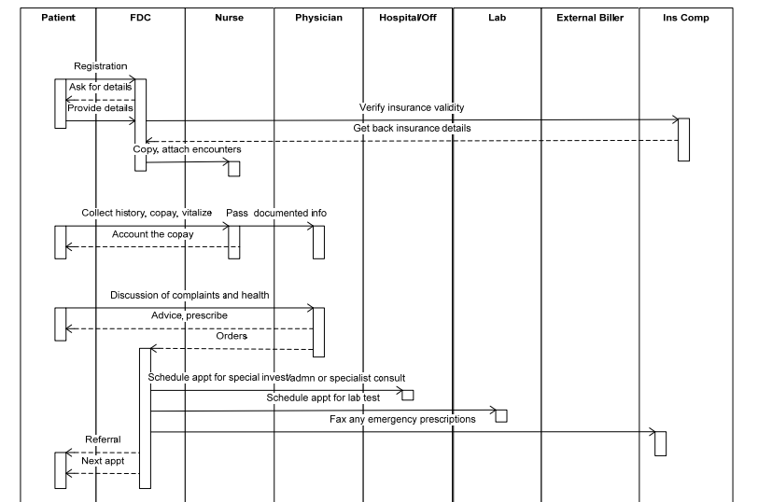
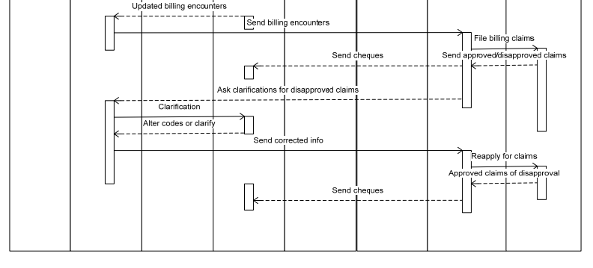
Figure 1: Interaction diagram within the healthcare offices

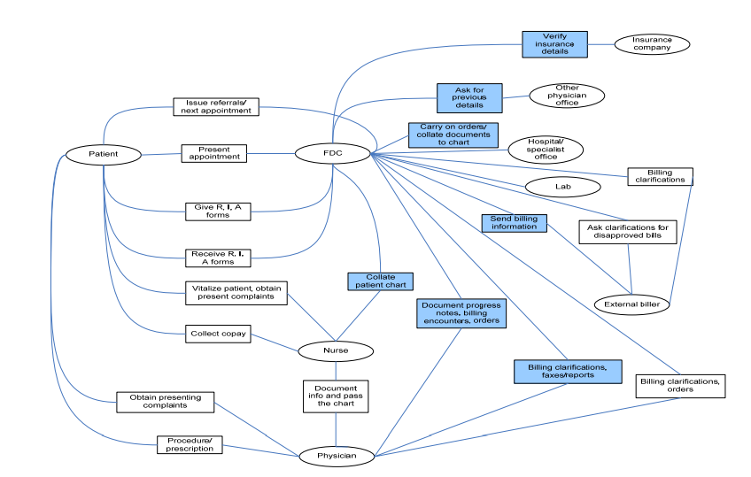

Figure 2: UML activity diagram for primary care reports

References
Ben-Assuli, O. (2015). Electronic health records, adoption, quality of care, legal and privacy issues and their implementation in emergency departments. Health Policy,119(3), 287-297.
Hsiao, C. J., Hing, E., & Ashman, J. (2014). Trends in Electronic Health Record System Use Among Office-based Physicians, United States, 2007-2012. US Department of Health and Human Services, Centers for Disease Control and Prevention, National Center for Health Statistics.
Lo, H. G., Newmark, L. P., Yoon, C., Volk, L. A., Carlson, V. L., Kittler, A. F., ... & Bates, D. W. (2007). Electronic health records in specialty care: a time-motion study. Journal of the American Medical Informatics Association, 14(5), 609-615.

